Some Useful Formulae & INFORMATION:

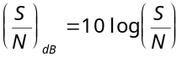

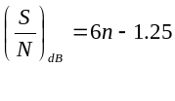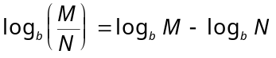
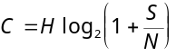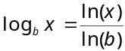
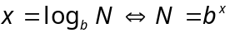

TABLE 1. Prefixes For Powers of Ten

Power of Ten | 10⁻¹² | 10⁻⁹ | 10⁻⁶ | 10⁻³ | 10⁻² | 10³ | 10⁶ | 10⁹ | 10¹²
Prefix | pico- | nano- | micro- | milli- | centi- | kilo- | mega- | giga- | tera-
Abbreviation | p | n | μ | m | c | K | M | G | T

Table 1
DB-25 pin assignments
Pin | Name | Signal | Pin | Name | Signal
1 | FG | Frame ground | 14 | STD | Secondary TD
2 | TD | Transmitted data | 15 | TC | Transmit clock
3 | RD | Received data | 16 | SRD | Secondary RD
4 | RTS | Request to send | 17 | RC | Receive clock
5 | CTS | Clear to send | 18 | - | Unassigned
6 | DSR | Data set ready | 19 | SRTS | Secondary RTS
7 | SG | Signal ground | 20 | DTR | Data terminal ready
8 | DCD | Data carrier signal | 21 | SQ | Signal quality detector
9 | - | Positive voltage | 22 | RI | Ring indicator
10 | - | Negative voltage | 23 | DRS | Data rate selector
11 | - | Unassigned | 24 | SCTE | Clock transmit external
12 | SDCD | Secondary DCD | 25 | BUSY | Busy
13 | SCTS | Secondary CTS

North American PCM Standards:
Sampling Rate: 8 kHz
Sampling Resolution: 128 levels

AT&T Digital Transmission Standards:

DS-1/T1 (1.544 Mbps/24 PCM voice channels)
DS-2/T2 (6.312 Mbps/96 PCM voice channels)
DS-3/T3 (44.736 Mbps/672 PCM voice channels)
DS-4/T4 (274.176 Mbps/4032 PCM voice channels)

